**Virtual Painter**

Submitted for the Partial Fulfillment of the Requirements for the Degree of

###### Bachelor of Technology

in Information Technology

#### J.C. Bose University of Science and Technology, Faridabad

**Submitted By:**

**Your name Rajeev**

**Sahil**

**Roll No**

**19/it22 19/it27**

anangpuria

**Under the Guidance of**

**(Project guide) (Principal)**

**DEPARTMENT OF Information Technology**

**B.S Anangpuria Institute of Technology & Management Alampur, Faridabad**

**Acknowledgement**

**Contents**

Abstract 4

Introduction 5

Motivation 6

Literature Review 7

Keywords and Definition 10

Methodologies 14

Challenges faced 21

Results 21

Conclusion 24

Future Scope 24

**Abstract**

Virtual Painting is a canvas-based platform on which we can draw by just motion of the hand Basically it just track the hand & capture the motion of fingers in this process the tip of the fingers are mainly used as the marker. It mainly uses is the OpenCV technology, which is backbone of Augmented Reality. Virtual Painting is fully developed in Python, it implements the basic and advance levels of python. The color tracking and detection process is used to achieve the output. Here the color marker is used to produce a mask on the original color canvas.

**Introduction**

Virtual drawing is where you can draw by recording hand movements with the camera. The monochromatic object on your fingertip is mainly used as a marker. OpenCV works on robotic systems. Pick up letters, identify objects on the conveyor belt and support self-driving cars. The language required for this project is python, which has a more comprehensive library and easy to use syntax and understanding of the basics and can be implemented in any open-source language cv support. The color tracking and detection process was used to achieve the goals of this project. The colored markers used here are detected and a mask is generated. Computer vision is an interdisciplinary field of science that studies how to build computers to achieve highlevel understanding of digital images or videos. It is used in applications that promote safety in mines, prevent drowning in swimming pools, process Google maps and street images, and deploy Google X robotics. OpenCV has been rebuilt from C. into a modern module compatible with STL and Boost.

**TECHNOLOGY USED:**

• **Language:-**This project will be developed in Python is a high-level, interpreted. Interactive and object-oriented scripting language. Python is designed to be highly readable. It uses English keywords frequently where as other languages use punctuation, and it has fewer syntactical constructions than other languages. It was mainly developed for emphasis on code readability, and its syntax allows programmers to express concepts in fewer lines of code.

➢ Modules Needed:

• **OpenCV:-** It is a huge open-source library for computer vision, machine learning, and image processing. OpenCV supports a wide variety of programming languages like Python, C++, Java, etc. It can process images and videos to identify objects, faces, or even the handwriting of a human. When it is integrated with various libraries, such as Numpy which is a highly optimized library for numerical operations. If not pre-installed then use command line :

**pip install opencv-python.** • **Numpy :-** It is a general-purpose array-processing package. It provides a high-performance multidimensional array object, and tools for working with these arrays. It is the fundamental package for scientific computing with Python. Besides its obvious scientific uses, Numpy can also be used as an efficient multi-dimensional container of generic data. To install it execute the following command in the command-line:

**pip install numpy.**

• **OS module :-** The OS module in Python provides functions for interacting with the operating system. OS comes under Python’s standard utility modules. This module provides a portable way of using operating system-dependent functionality. The *os* and *os.path* modules include many functions to interact with the file system. It is preinstalled but still if not then use command:

**pip install os-sys**.

• **Hand Tracking :-** It is most important part of this project Hand tracking is the process in which a computer uses computer vision to detect a hand from an input image and keeps focus on the hand’s movement and orientation. Hand tracking allows us to develop numerous programs that use hand movement and orientation as their input.We tend to write the same code in different projects to perform hand tracking as part of our program. Creating a hand tracking module solves this problem since we write the code once.We then convert this piece of code into a module. We can import this module into any python project that we are working on and it will perform hand tracking.

Hand Tracking uses **MediaPipe** module which is basics of hand tracking module, it Object Detection is one of the leading and most popular use cases in the domain of computer vision. Several object detection models are used worldwide for their particular use case applications. Many of these models have been used as an independent solution to a single computer vision task with its own fixed application. Combining several of these tasks into a single end-to-end solution, in real-time, is exactly what MediaPipe does.

MediaPipe is an open-source, cross-platform Machine Learning framework used for building complex and multimodal applied machine learning pipelines. It can be used to make cutting-edge Machine Learning Models like face detection, multi-hand tracking, object detection, and tracking, and many more. MediaPipe basically acts as a mediator for handling the implementation of models for systems running on any platform which helps the developer focus more on experimenting with models, than on the system.

Hand tracking using MediaPipe involves two stages:

**Palm detection** - MediaPipe works on the complete input image and provides a cropped image of the hand.

**Hand landmarks identification** - MediaPipe finds the 21 hand landmarks on the cropped image of the hand.

The 21 hand points that MediaPipe identifies are shown in the image below: 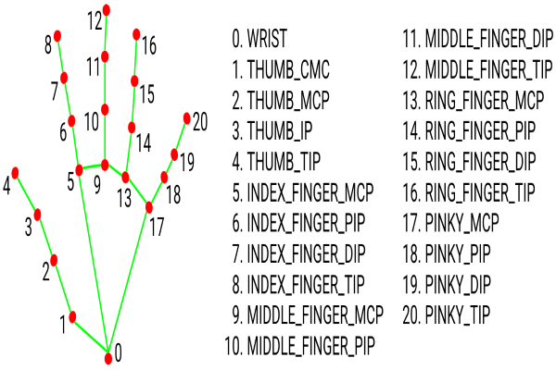

**PURPOSE AND MOTIVATION**

Drawing or Sketching using hand is everyone’s wish. Some or the other time we imagine writing in air using our hand. So, here came the project from this concept where we create a canvas and pick the colors required using our hand and draw the required design or write anything you wish. Gestures are non-verbal information used to improve computer language understanding. Human gestures are perceived via sight, and computer vision is used to research different gestures. The assignment takes gain of this shortcoming and makes a specialty of developing a motion to text converter able to serving as software for clever wearables to document from the air. The device will use computer vision to music the path of the finger, and on this manner, you will write from the top down. The generated text also can be used for extraordinary purposes, which includes sending messages, emails, etc. it is going to be a powerful approach of communique for the listening to impaired. it's far an powerful approach of communique that gets rid of the need to put in writing and reduces using cell telephones and laptops. The library has more than 2400 best algorithms, which includes comprehensive set of classic and state-of-the- art computer vision and machine learning algorithms. Most of these algorithms are used to detect and recognize faces, identify objects, classify human activities in videos track camera movements, track moving objects, extract 3D one’s. Python is one of the high-level-general- purpose programming language. Object-oriented approach mainly to help programmers to write effectively as well as large scale.

BACKGROUND

Analysis of data for the use of this research was done using statistical calculation methods aided by the use of Microsoft Excel and Statistical Package for Social Scientists Sketching on Air is possible through our trending technology namely open cv, python. Open cv is mainly known as an computer eye. Developing an interface between human hand and the system using open cv techniques and python language to pick the color and draw using hand on the developed drawing area. Computer vision is a science of teaching computers to see. With the state of the art algorithms, this technology is behind many applications like self-driving cars, image recognition, medical diagnosis etc. The excellent issue about laptop vision is that those technologies are used to locate cancer cells, that may help save lives with the aid of including a filter for your face and supplying you with delight. There are also lots of exciting and useful packages. In this article, we will do create a virtual painting app without the using keyboard, and just by drawing on-air that will be outputted on the screen. we demonstrated how to make a virtual paint application using OpenCV tool. We had given lower and upper ranges of red color so we can use red color as a pencil to draw virtually and it reflects on your system screen. Although my drawings are bad, it’s fun to implement. Writing is a cohesive form of conversation which can efficaciously bring our mind. Typing and writing are the usual methods of recording data these days. Characters or words are written in the unfastened area with a marker or finger. It differs from traditional writing methods in that the pen does now not circulate up and down. With the development of clever wearable gadgets, the virtual global can now be managed by means of human gestures. those wearable gadgets can understand and understand our moves. spotting and deciphering a non-stop sequential gesture circulation from the given set of input statistics is gesture popularity.

**LITERATURE REVIEW**

In [1] Author proposed objects color detection and masking it with morphological operations along with that providing task bar for various color.

It is still very challenging because it is detecting only one color as marker if any other single point of color detected elsewhere it starts changing marker location and captures random trajectory.

In[2]Author is using different techniques of fingertip recognition along with that he is also creating a dataset by cutting a video into different separate images and also labelling the dataset manually further he is creating a module by training the dataset with pre trained model. But it is not that accurate.

In [3], the system proposed used the depth and color information from the Kinect sensor to detect the hand shape. As considering gesture recognition  with the Kinect sensor. It is a very challenging process. Because the resolution of kinetic sensor is very low.

It is suitable for humongous object, e.g., the human body.

 But for a object/thing like a finger it is not suitable.

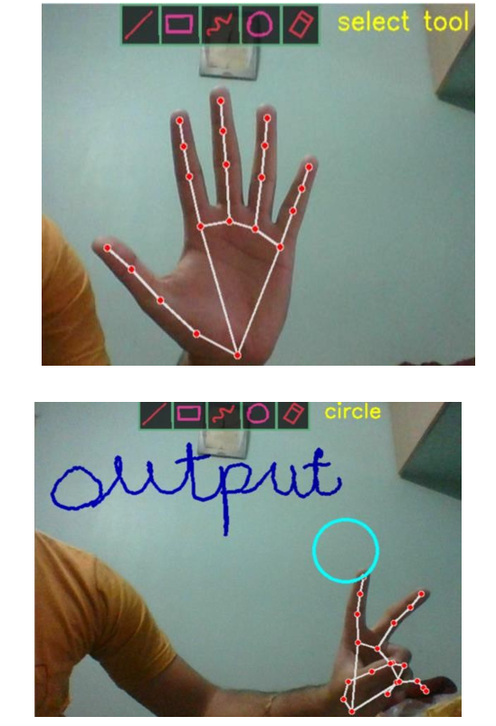

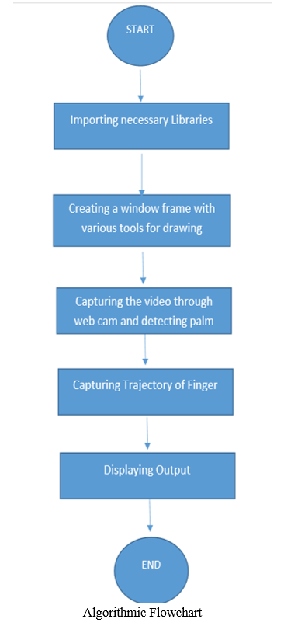

**ARCHITECTURE**

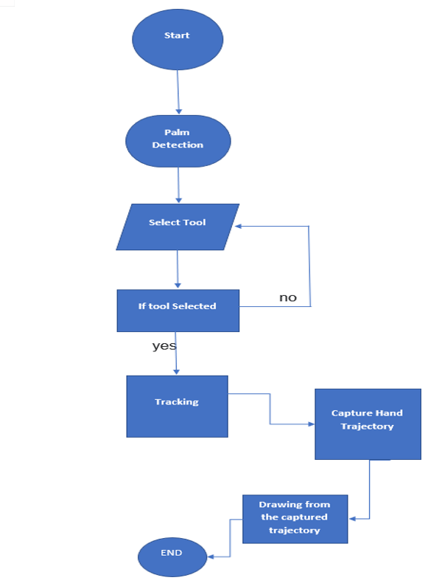

**SOFTWARE AND HARDWARE REQUIREMENTS**

**Software Requirements:**

* OS: Windows
* IDE: Visual Studio Code
* Language: Python
* Particular GUI Library: Tkinter

**Hardware Components:**

* Processor - Dual Core
* Hard Disk – 500GB
* Memory - 4GB RAM
* Mouse - Any Standard
* Keyboard - Any Standard
* Monitor -Any color monitor

**FUTURE SCOPE/WORK**

This system could be used as an alternative for teaching software used by teachers. If further interpreted various virtual based physical games could be made. Controlling the robot using gestures considered as one of the interesting applications in this field proposed a system controlling a robot using hand pose signs. The orders could be given to robot  to execute some task, where each sign has a specific meaning and represents different function

##### **Conclusion**

The system has the potential to challenge traditional writing/teaching methods. The ultimate goal is to create a computer vision machine learning application that promotes Human computer interaction also named Man-Machine Interaction refers to the relation between the human and the computer or more precisely the machine. System functionality referred to the set of functions or services that the system equip is to the users while system can operate and perform specific user purposes activity efficiently such as virtual drawing.